Project Design Phase

Solution Architecture
Date: 15 February 2025
Team ID: LTVIP2025TMID38720
Project Name: TrafficTelligence – Advanced Traffic Volume Estimation with Machine Learning
Maximum Marks: 4 Marks

Solution Architecture:
Solution architecture is a complex process – with many sub-processes – that bridges the gap between business problems and technology solutions. Its goals are to:
• Find the best tech solution to solve existing business problems.
• Describe the structure, characteristics, behavior, and other aspects of the software to project stakeholders.
• Define features, development phases, and solution requirements.
• Provide specifications according to which the solution is defined, managed, and delivered.
Architecture Diagram:

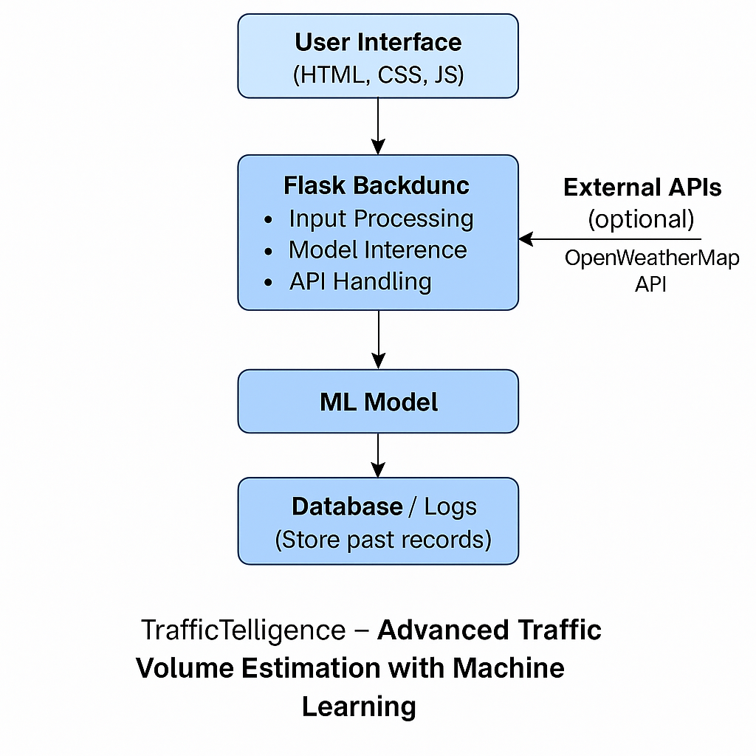
Figure 1: Architecture and data flow of the TrafficTelligence application.

